High Speed Commercial Vacuum Friction Feeders
VF200 | VF280
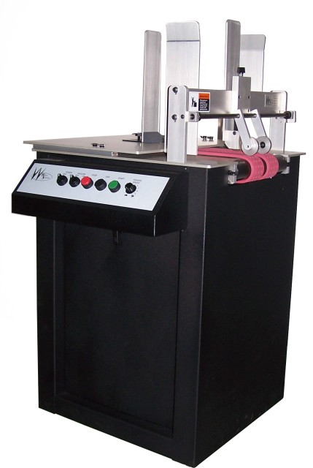  See the VF200 in action!  The VF200 offers a radically innovative design not available anywhere else.  Every part in this feeder - from the precision machined guides, to the sealed shaft locking collar bearings - was designed to take an outstanding amount of abuse. Over 50 inches of two (2) 2-1/2 inch wide belts offer an astonishing amount of friction. Add vacuum to the equation and you have a machine capable of pulling any product.  Like all Walco Systems products, the Evolution series feeders are designed for the high capacity use demanded by today's commercial environment. | 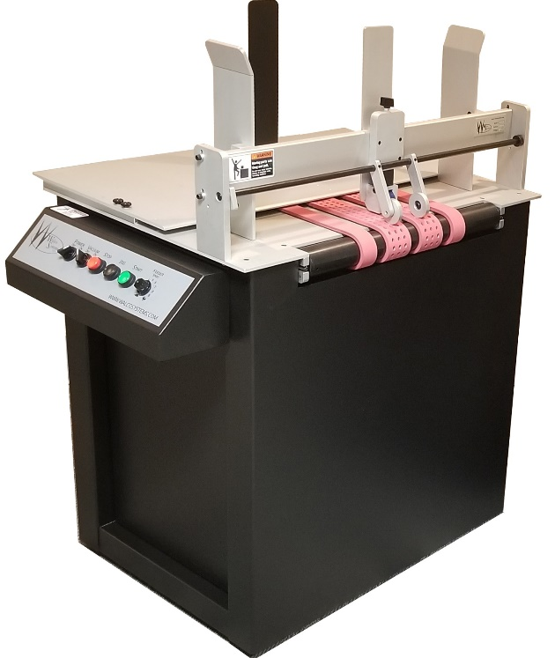  Employing every concept that makes up the VF200, the VF400 ups the ante and allows for wider pieces to be fed. Designed primarily for cardboard, this machine allows products to contact 180 square inches of natural gum rubber belting.
Specifications  VF200  Material Size: Min. 3"W x 5"L - Max 19.5"W x 28"L  Material Thickness: 1" Max (In Standard Configuration)  Electrical: 110 VAC 1-Phase 10 Amp Circuit  Interlock: Dry Contact (Low Volt) Standard  Operator Controls: Power (on/off), Vacuum (on/off), Stop, Jog, Start, Feed Speed  Physical: 24"L x 23.5"W x 33-36" H | Specifications  VF280  Material Size: Min. 3"W x 5"L - Max 37.5"W x 28"L  Material Thickness: 1" Max (In Standard Configuration)  Electrical: 110 VAC 1-Phase 10 Amp Circuit  Interlock: Dry Contact (Low Volt) Standard  Operator Controls: Power (on/off), Vacuum (on/off), Stop, Jog, Start, Feed Speed  Physical: 24"L x 50.5"W x 33-36" H

