VF200-AL AUTOLOADER

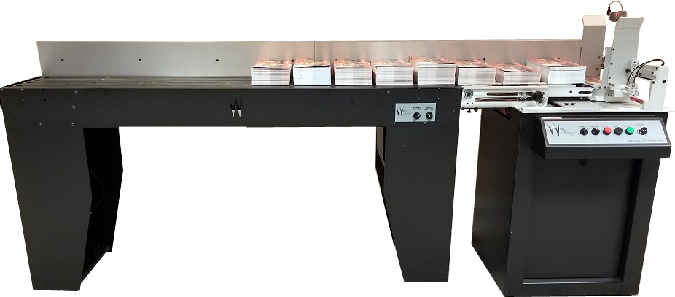

The VF200AL was designed with productivity in mind. The patented VF200AL loads large stacks of product into the feeder hopper instead of shingled product. This allows for greater yield of each fill of the loader and reduced effort to fill the loader.
We designed the VF200AL to operate exactly like our celebrated VF series feeders. Several enhancements have been made to the VF200AL feeder that set it apart from our standard VF200 feeder. Precision ball bearing side guides offer smooth adjustments, and deck risers eliminate the need to raise or lower the side guides for different sized products. Rapid setup and easy controls allow users to change jobs quickly. For low production work, the loading section of the feeder can be disconnected rapidly and rolled away on its casters.

Specifications

VF200AL
Material Size: Min. 3"W x 5"L - Max 14"W x 14"L (VF200 Only: Min. 3"W x 5"L - Max 19.5"W x 28"L)
Material Thickness: 1" Max (In Standard Configuration)
Electrical: 110 VAC 1-Phase 10 Amp Circuit
Interlock: Dry Contact (Low Volt) Standard
Operator Controls: Power (on/off), Vacuum (on/off), Stop, Jog, Start, Feed Speed
Physical: 105"L x 23.5"W x 33-36" H

